Gregory 1
Brigitte Gregory
Professor Whitehurst
Creative Writing
9/20/2026

The New Orleans Legend

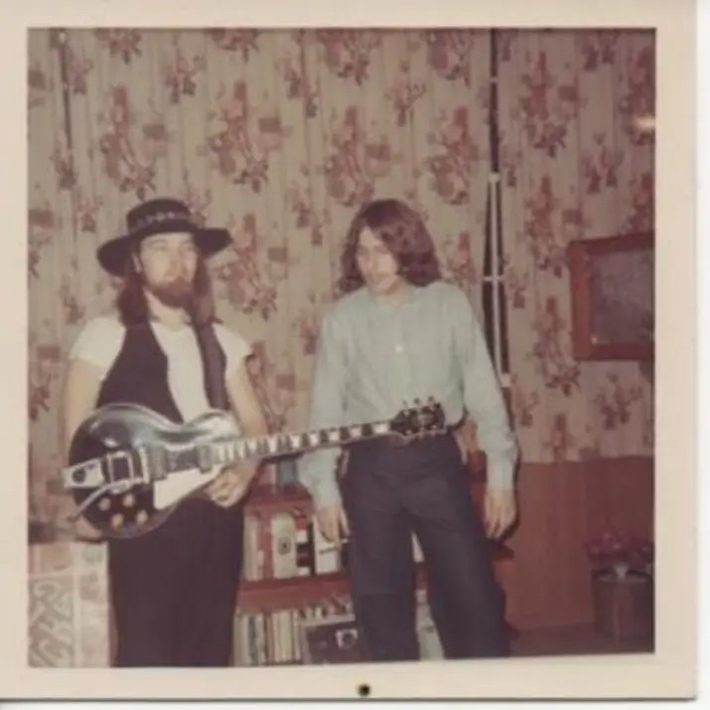
His name is Bill Gregory, but he went by Billy; he was short, broad-shouldered, and stocky. He always wore cowboy boots and a big, fancy cowboy hat on stage. Billy was born on February 17th, 1950, which makes him 76 years old today. He was raised an “army brat” and traveled all throughout his life. At 13, he eventually left home for Los Angeles, California, where he joined the union as a musician. His family was scattered, with multiple stepbrothers, sisters, and parents, so no one fully understood his past, which kept him mysterious.

Gregory 2


In the late 1980s, the United States Army had admitted one of its best troopers. Billy always spoke highly of his time in service, enjoyed the military, and did very well; he would reminisce about the heat in Egypt and how it could fry an egg within seconds if you cracked it on the hood of your car. He eventually completed special forces training and many other accomplishments. During his time in the reserves, I was born that September in 1990. He decided he didn’t want to be deployed that year to Desert Storm so he could be with my mother and me after my birth.
Billy was the life of the party. If he drank from the bar, he always enjoyed a glass of Conac neat, which I always thought was fancy for a musician on Bourbon Street. Everywhere we went, people knew him, and he loved to talk, sometimes too long, which made me uncomfortable, but I also thought it was funny. I remember the first time I saw him play in 1993. I was 3 years old in Bologna, Italy, on his tour. He was opening for B.B. King, a very famous American jazz and blues artist. I danced for hours, and everyone backstage was so sweet to me. The smell of chocolate and cigarettes filled the night air. Bologna was different than America. Children stayed up late with their parents, enjoying the music and good food, unlike the strict bedtimes in the United States. I felt free, accepted, and loved the culture.

Gregory 3

After touring Europe, we finally came back home to New Orleans, near the French Quarter, where he worked full-time playing with several different bands. I didn’t see him much growing up since he was so busy, but when I was little, he would always wake me up early on his days off to go fishing. One time we had to dig for worms to bait the fish, and he made me walk across a railroad track over Lake Pontchartrain. I remember feeling so scared with my little 6-year-old legs that I might fall through the gaps in the railroad ties. Even though I was scared and nervous, I loved those moments with him. I caught my first catfish that day, and he was so proud.
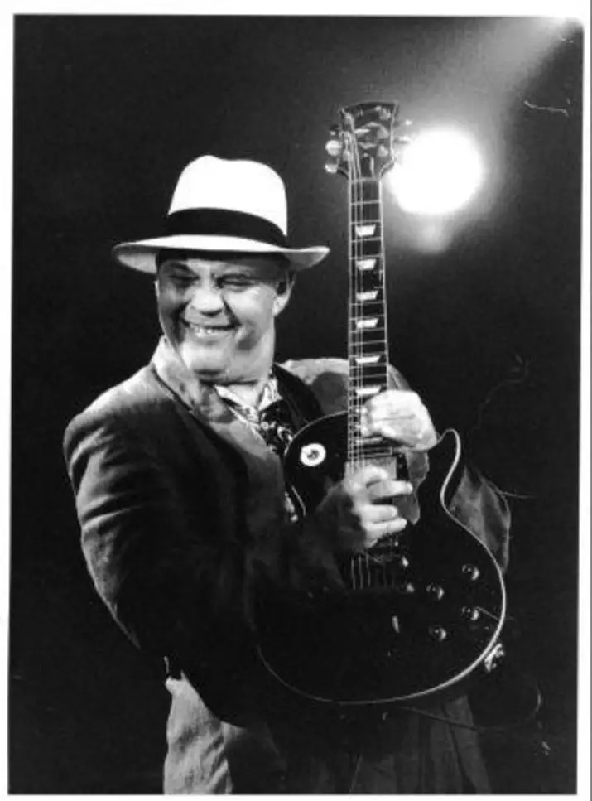

Gregory 4

When I became older, I moved away to Atlanta, Georgia. I saw him every Christmas and every Spring Break, but we always talked on the phone. He told me wild stories about his travels and the nightlife. It always seemed like he was such a huge celebrity out there. In my 20s, I would eventually move back to bartend on Bourbon Street by his side. My friends would travel from all over nearby southern colleges to come see him play in the French Quarter.
In some performances, he did crazy tricks with the guitar, like using the microphone stand as his pick, or playing it upside down behind his back. The crowd loved it, and so did I! Billy Gregory was a legend to many. He earned a spot in the New Orleans Hall of Fame and set many solo records, writing and producing all the music himself. New Orleans was his home for over 30 years, even throughout his travels.
Billy has played in over 70 bands throughout his music career, writing chords, lyrics, and sheet music for other musicians. Professionally, he has played with well-known musicians such as Jefferson Airplane, Professor Longhair, It’s a Beautiful Day, The Doors, and many more. His stories are so intriguing and filled with fantasy and excitement. Growing up as a musician across many eras is a rare, unique experience that people love to admire and listen to.
Billy Gregory now lives in the Ozark Mountains of Arkansas, retired, with his daughter and grandchildren. He has lived a very fulfilling life and is loved and admired by many. Eight years ago, he was diagnosed with Dementia and unfortunately has forgotten how to write and play music entirely.

Gregory 5

As he forgets day-to-day events and everyday activities, he still remembers many stories from his meaningful career and his favorite hobby as a legendary musician in New Orleans, Louisiana. His stories and memorable life will always be a part of me, my children, and many fans and friends who loved him dearly.

